Ex.No:10: PERFORMANCE ANALYSIS OF FM SYSTEM UNDER GAUSSIAN WHITE NOISE USING MATLAB
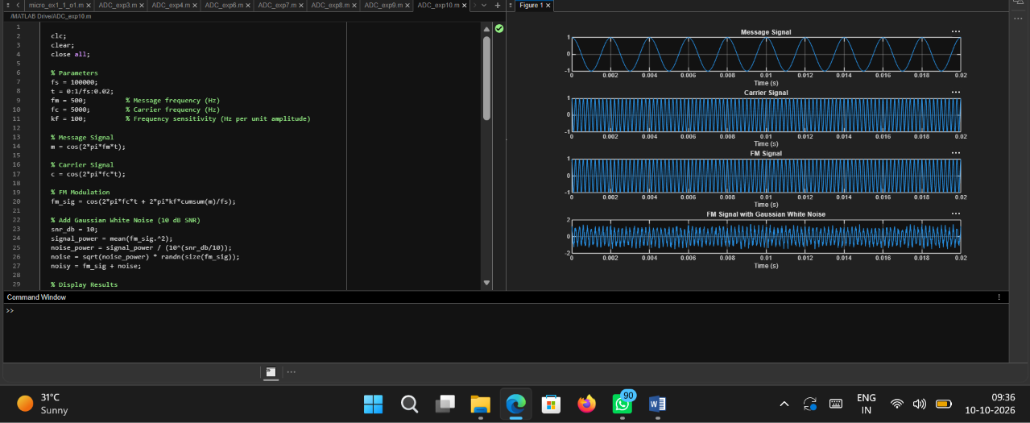
Objective 1:

Code:
clc;
clear; close all;
% Parameters fs = 100000;
t = 0:1/fs:0.02;
fm = 500; % Message frequency (Hz)
fc = 5000; % Carrier frequency (Hz)
kf = 100; % Frequency sensitivity (Hz per unit amplitude)

% Message Signal
m = cos(2*pi*fm*t);
% Carrier Signal
c = cos(2*pi*fc*t);
% FM Modulation

fm_sig = cos(2*pi*fc*t + 2*pi*kf*cumsum(m)/fs);

% Add Gaussian White Noise (10 dB SNR) snr_db = 10;
signal_power = mean(fm_sig.^2);
noise_power = signal_power / (10^(snr_db/10)); noise = sqrt(noise_power) * randn(size(fm_sig)); noisy = fm_sig + noise;
% Display Results figure;

subplot(4,1,1);
plot(t,m); title('Message Signal'); xlabel('Time (s)'); grid on;

subplot(4,1,2);
plot(t,c); title('Carrier Signal'); xlabel('Time (s)'); grid on;

subplot(4,1,3); plot(t,fm_sig); title('FM Signal'); xlabel('Time (s)'); grid on;
subplot(4,1,4); plot(t,noisy);
title('FM Signal with Gaussian White Noise'); xlabel('Time (s)');
grid on;

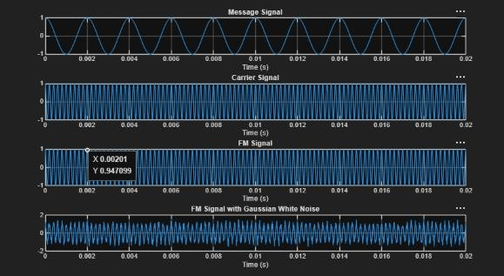
Output:

